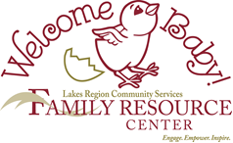

Newborn Navigation Program Referral Form

Please forward referral form to:
Carol Stone
Family Resource Center of Central New Hampshire
719 North Main Street
Laconia, NH 03246
Email: carol.stone@lrcs.org
Phone: 603-581-1565

Newborn Navigation, through the FRC of Central NH is a home visiting option
for families with newborns in Belknap and Lower Grafton counties.
Families are offered up to 3 home visits during pregnancy and post-partum periods.
This is a free, voluntary and confidential program.

Enrolled families receive a lovely tote bag, with gifts for baby, mom and family on the first visit.

Family Name |  | Date of Referral
Family Address |  | City/Town
Phone Number |  | Email Address
Referral Name |  | Phone Number
Referral Source

Parent’s First Name(s)
Sibling’s First Name(s) and ages

Baby’s Due Date or Date of Birth
Baby’s Name |  | Gender: | MALE / FEMALE / UNKNOWN

Do you have any concerns at this time?

(Internal Agency Use Only)

Date referral received: |  | Newborn Navigator Visitor
Initial Visit Date: |  | Second Visit Date: |  | Third Visit Date:

NOTES: ___________________________________________________________________________________________________________
___________________________________________________________________________________________________________________

